TransLingua: AI-Powered Multi-Language Translator

Project Overview
TransLingua: AI-Powered Multi-Language Translator is a web-based application developed to provide intelligent, fast, and context-aware language translation using advanced Large Language Models (LLMs). The system is built using Streamlit for the front-end interface and Google’s Gemini 1.5 Flash model for AI-powered translation.
In today’s interconnected world, effective communication across languages is essential for business, education, healthcare, travel, and international collaboration. Traditional translation systems often rely on rule-based or statistical methods that translate text word-for-word without understanding deeper context. This frequently results in grammatical errors, incorrect tone, and loss of meaning.
TransLingua overcomes these limitations by leveraging transformer-based generative AI models capable of understanding context, sentence structure, semantics, and intent. Instead of simple dictionary-based substitution, the application generates translations by analyzing the full meaning of the input text. This results in more natural, fluent, and human-like output.
The system operates through a simple yet powerful workflow:
- The user enters text into the Streamlit interface.
- The user selects the source language.
- The user selects the target language.
- A structured prompt is generated dynamically.
- The prompt is sent to the Gemini LLM via API.
- The model processes the request and generates translated content.
- The translated text is displayed instantly on the interface.
The application architecture follows a clean and lightweight design:

Architecture
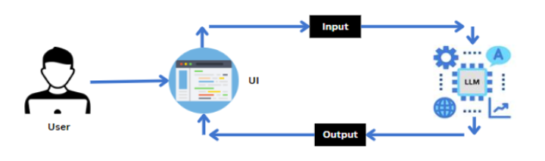
One of the key strengths of TransLingua is its ability to maintain contextual meaning. Since it uses a modern generative model, it understands grammar patterns, idiomatic expressions, and domain-specific terminology. This makes it suitable for translating not only casual conversations but also academic documents, business communications, and technical content.
From a technical perspective, the project demonstrates:
- Integration of a cloud-based AI model using API configuration
- Secure handling of API keys using environment variables
- Real-time interaction between UI and backend logic
- Prompt engineering for accurate task execution
- Deployment of AI services within lightweight web frameworks
The system is designed to be scalable and extensible. While the current version supports text translation between selected languages, it can be enhanced to include:
- Voice-to-text translation
- File upload translation (PDF, DOCX)
- Real-time conversation translation
- Cloud deployment for global accessibility
- Multi-modal input support
TransLingua serves as a practical demonstration of how Generative AI can be integrated into real-world applications to solve communication challenges. By combining Streamlit’s interactive interface with Gemini’s powerful natural language capabilities, this project highlights the future of AI-driven multilingual communication systems.
In summary, TransLingua is not just a translation tool but a proof-of-concept that showcases how modern AI technologies can bridge global language barriers efficiently, accurately, and intelligently.

Use Cases and Scenarios
TransLingua is designed to support multilingual communication across various domains including business, education, travel, healthcare, and international collaboration. The following use cases demonstrate how the system can be applied in real-world environments.
Use Case 1: Global Business Expansion
Scenario:
A company planning to expand into international markets needs to communicate with customers, partners, and stakeholders in multiple languages.
Application of TransLingua:
- Translate marketing materials into regional languages.
- Convert product descriptions and brochures.
- Translate business proposals and contracts.
- Communicate with global clients via email.
Benefits:
- Ensures consistent brand messaging across languages.
- Reduces dependency on manual translators.
- Speeds up international communication.
- Improves customer engagement in local markets.
By providing fast and context-aware translations, TransLingua helps organizations scale globally without language barriers.

Use Case 2: Academic Research and Collaboration
Scenario:
Researchers from different countries collaborate on joint research projects and publish papers in international journals.
Application of TransLingua:
- Translate research papers and academic articles.
- Convert technical documents between languages.
- Translate communication among research teams.
- Assist students in understanding foreign research materials.
Benefits:
- Facilitates cross-border collaboration.
- Improves access to global knowledge.
- Saves time in translating complex academic content.
- Supports multilingual education environments.
Since the Gemini model understands context and technical terminology, it provides more accurate translations for scholarly content compared to simple word-based systems.

Use Case 3: Travel and Tourism Assistance
Scenario:
Travelers visiting foreign countries struggle to understand local languages when reading signboards, menus, or instructions.
Application of TransLingua:
- Translate restaurant menus.
- Understand public transport instructions.
- Read hotel guidelines and tourism brochures.
- Communicate basic information with locals.
Benefits:
- Enhances travel experience.
- Reduces confusion in unfamiliar environments.
- Improves safety and navigation.
- Makes international travel more accessible.
TransLingua acts as a quick and reliable digital travel companion.

Use Case 4 : Content Creation and Social Media
Scenario:
Content creators and digital marketers want to reach international audiences.
Application of TransLingua:
- Translate blog posts.
- Convert social media captions.
- Adapt promotional campaigns for different regions.
Benefits:
- Expands audience reach.
- Increases engagement.
- Improves global brand visibility.
Prerequisites
To successfully develop and understand the TransLingua project, the following prerequisites are required:
1. Software Requirements
- Python 3.8 or higher
- Anaconda (Recommended for environment management)
- Streamlit
- Internet connection (for API access)

2. Required Python Libraries
Install the following packages using pip:
pip install streamlit google-generativeai python-dotenv
requirements.txt:
streamlit
google-generativeai
python-dotenv

3. Knowledge Requirements
Basic understanding of:
- Python programming
- Large Language Models (LLMs)
- Google Gemini / Generative AI API
- Streamlit framework
- API key configuration and environment variables
- Basic web application workflow

These prerequisites ensure smooth development, integration, and deployment of the AI-powered translation system.
Project Flow
The TransLingua project works in a simple step-by-step process:
- User Opens the Application
The user runs the Streamlit app in the browser.
- User Enters Text
The user types the text that needs to be translated.
- Select Languages
  - Choose the source language (original language).
  - Choose the target language (language to translate into).
- Click Translate Button
The user clicks the Translate button.
- System Creates a Prompt
The application prepares a translation request for the Gemini AI model.
- Model Processes the Text
The Gemini model understands the input and generates the translated text.
- Display Output
The translated result is shown instantly on the screen.

User
↓
Streamlit UI
↓
Input Validation
↓
Prompt Construction
↓
Gemini LLM API Call
↓
Translation Generated
↓
Display Output
Dataset
TransLingua does not use a traditional dataset like image classification or machine learning training projects.
Since the application uses Google’s Gemini Large Language Model (LLM), the model is already pre-trained on large-scale multilingual text data by Google.

Key Points:
No custom dataset is required.
The Gemini model is pre-trained on:
  - Books
  - Articles
  - Web content
  - Multilingual text corpora
The system works using real-time user input.
Translation is generated dynamically based on prompt instructions.
So, instead of training a model, this project focuses on integrating and using a pre-trained LLM via API.

Implementation Steps
Below are the main steps followed to implement the TransLingua project:

Step 1: Create Project Folder
Create a folder named:
TransLingua/
Inside it, create:
translang.py
requirements.txt

Step 2: Install Required Libraries
Install necessary packages:
pip install streamlit google-generativeai python-dotenv
Add them in requirements.txt:
streamlit
google-generativeai
python-dotenv

Step 3: Generate API Key
- Go to Google AI Studio.
- Click on “Get API Key”.
- Create API key.
- Copy the key.
- Store it securely in .env file.

Step 4: Configure the API
Import necessary libraries:
import streamlit as st
import google.generativeai as genai
import os
from dotenv import load_dotenv
Load and configure API key:
load_dotenv()
genai.configure(api_key=os.getenv("GOOGLE_API_KEY"))

Step 5: Initialize the Model
model = genai.GenerativeModel("gemini-1.5-flash")

Step 6: Create Translation Function
def translate_text(text, source_language, target_language):
prompt = f"Translate the following text from {source_language} to {target_language}: {text}"
response = model.generate_content(prompt)
return response.text

Step 7: Build Streamlit UI
- Add text input field
- Add language dropdown menus
- Add translate button
- Display translated result

Step 8: Run the Application
Open terminal and run:
streamlit run translang.py
The application opens in the browser at:
Local URL:
http://localhost:8501
Network URL:
http://192.168.0.100:8501
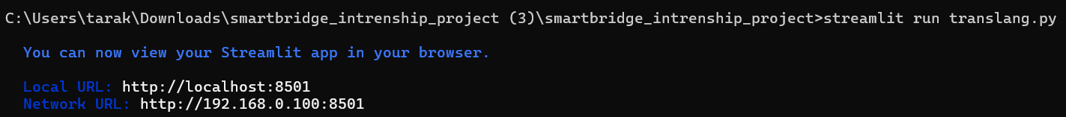
Backend Logic (translang.py)
- Load environment variables and configure API key.
- Initialize Gemini model (gemini-1.5-flash).
- Create translation function using generate_content().
- Handle user inputs and display output.
Deliverables
- Streamlit Application: translang.py
- requirements.txt
- Functional translation system
OUTPUT :
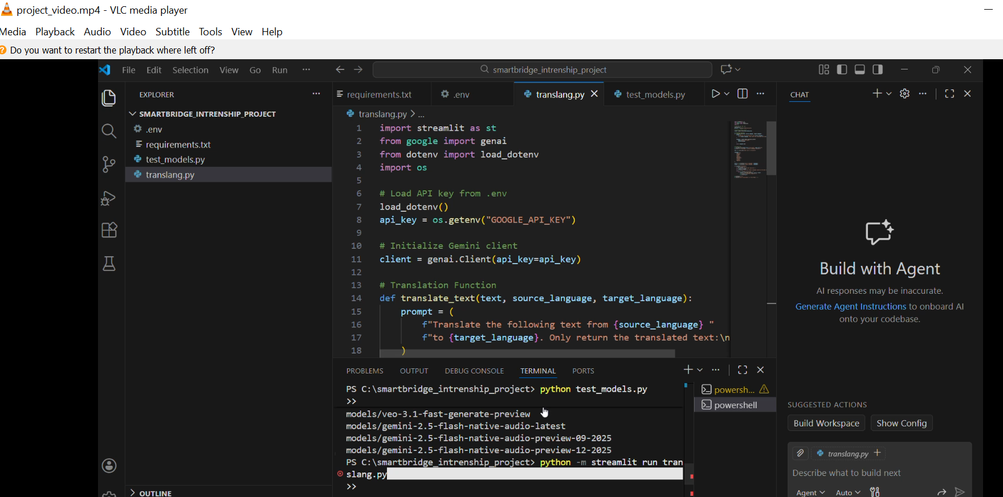
Now, the application will open in the web browser,
Home page
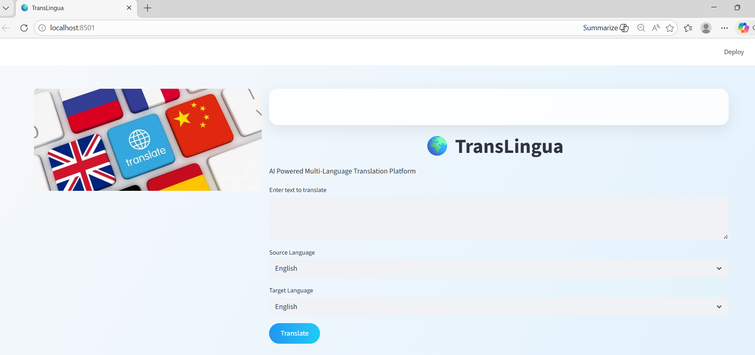
Language selection
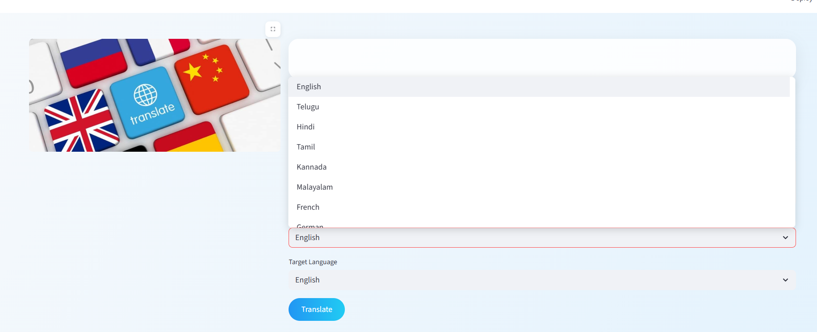
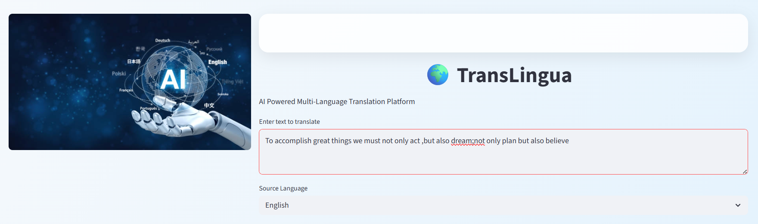
We can select any source language and target language,
Example 1 : German(selected as target language)
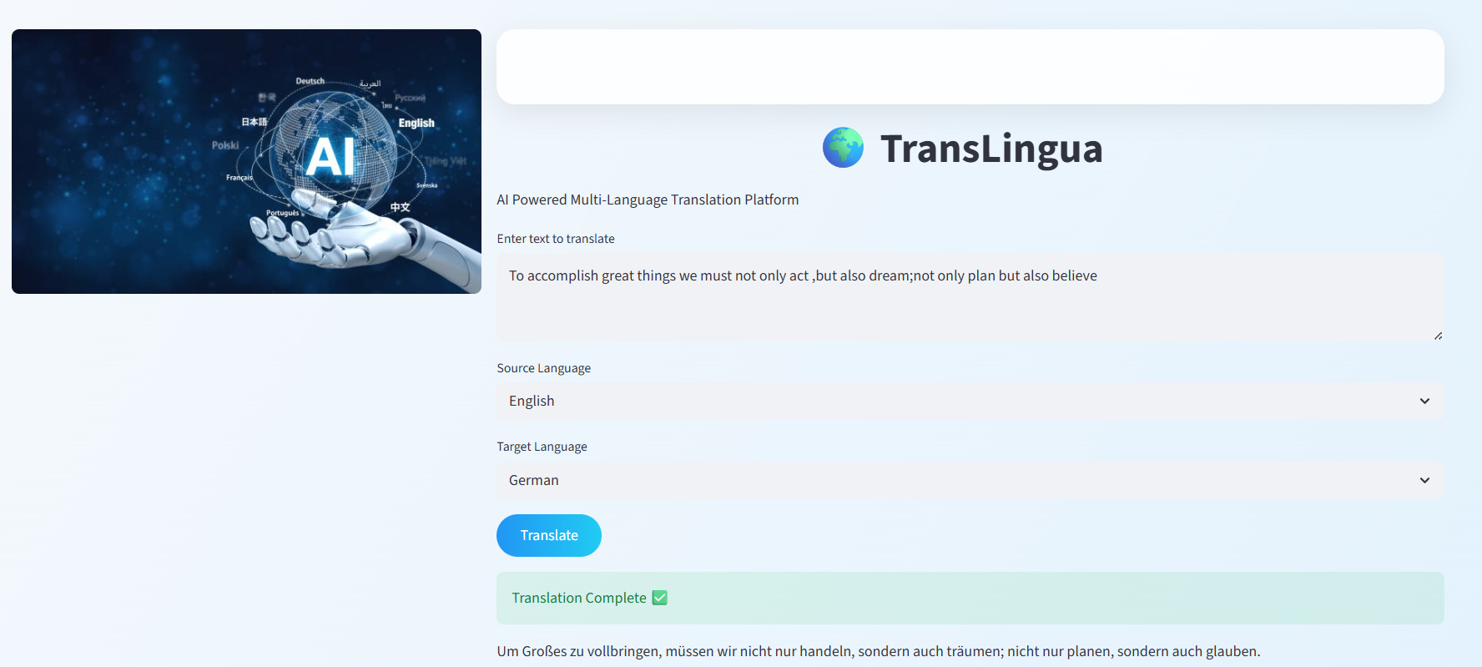
Example 2 : Tamil
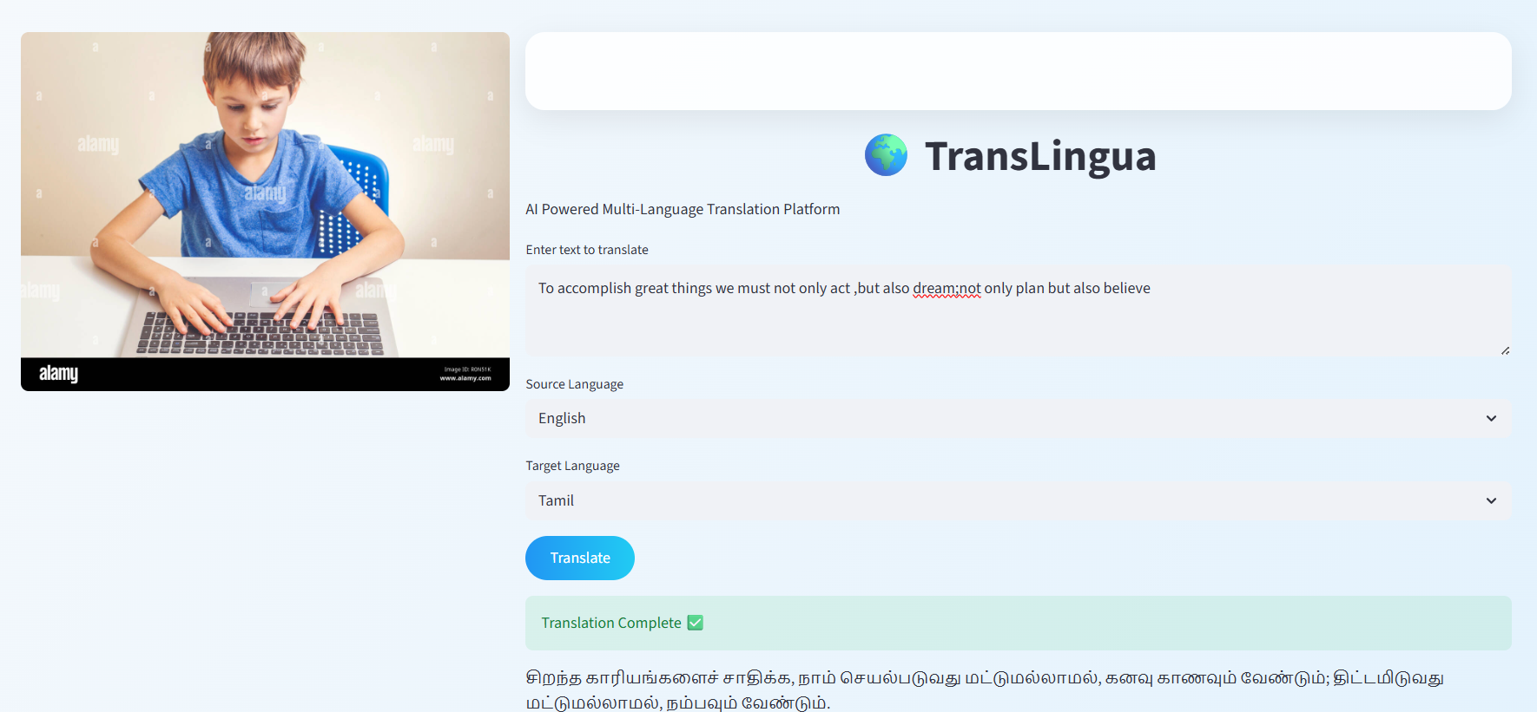
Example 3 : French 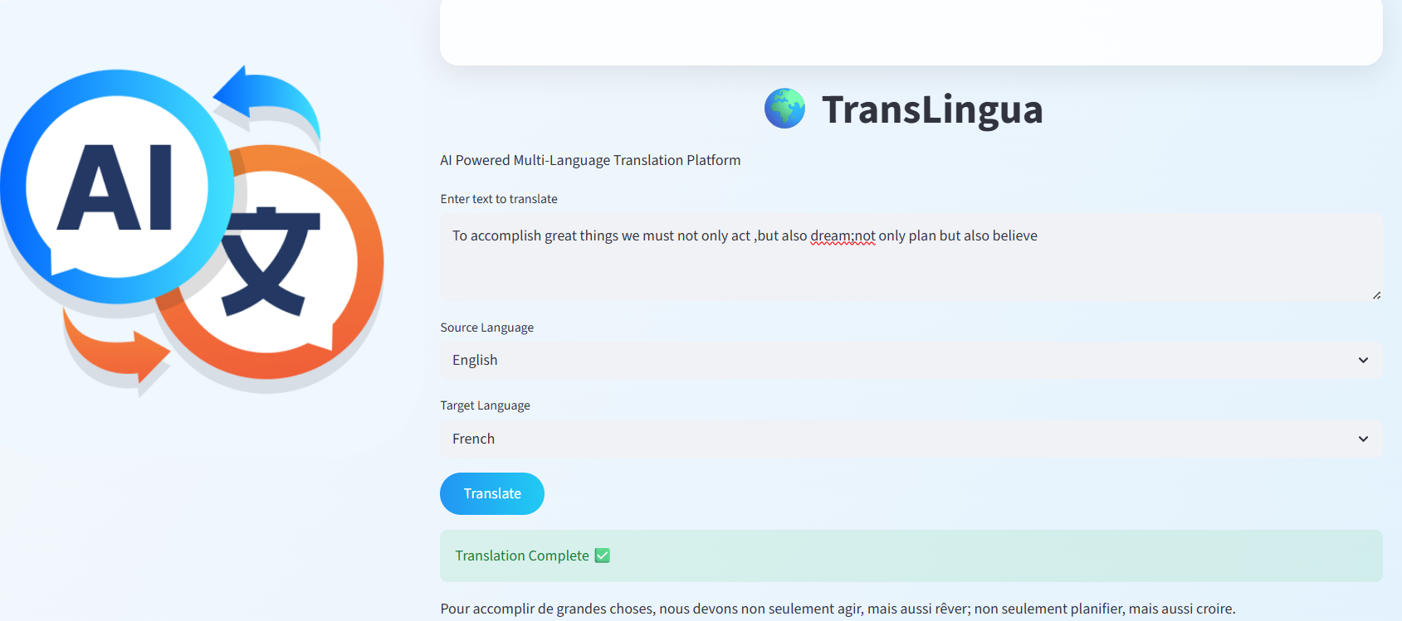
- We can change the source language too.
Here I changed the source language english to telugu
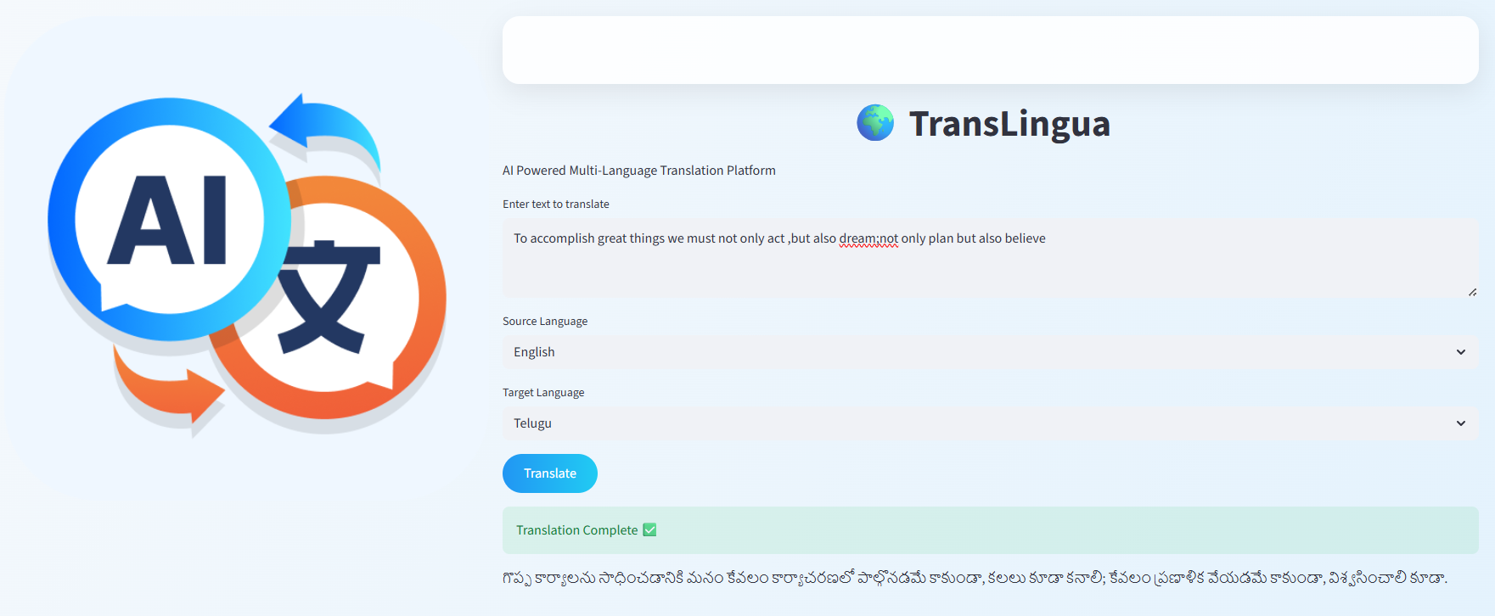

Example code:

✅ translang.py
import streamlit as st
from google import genai
from dotenv import load_dotenv
import os
import random
from PIL import Image

# -------------------------
# Load API Key
# -------------------------
load_dotenv()
api_key = os.getenv("GOOGLE_API_KEY")
client = genai.Client(api_key=api_key)

# -------------------------
# Translation Function
# -------------------------
def translate_text(text, source_language, target_language):
prompt = (
f"Translate the following text from {source_language} "
f"to {target_language}. Only return the translated text:\n\n{text}"
)

response = client.models.generate_content(
model="gemini-2.5-flash",
contents=prompt
)

return response.text

# -------------------------
# Page Configuration
# -------------------------
st.set_page_config(
page_title="TransLingua",
page_icon="🌍",
layout="wide"
)

# -------------------------
# Light Professional Background
# -------------------------
st.markdown("""
<style>
.stApp {
background: linear-gradient(120deg, #f6f9fc, #e3f2fd);
font-family: 'Segoe UI', sans-serif;
}

.glass-box {
background: rgba(255, 255, 255, 0.85);
padding: 40px;
border-radius: 20px;
box-shadow: 0px 10px 30px rgba(0,0,0,0.08);
}

h1 {
text-align: center;
color: #0d47a1;
}

.stButton>button {
background: linear-gradient(90deg, #2196f3, #21cbf3);
color: white;
border-radius: 25px;
padding: 10px 25px;
border: none;
font-weight: bold;
}

.stButton>button:hover {
background: linear-gradient(90deg, #1976d2, #00bcd4);
}
</style>
""", unsafe_allow_html=True)

# -------------------------
# RANDOM IMAGE EVERY REFRESH
# -------------------------
image_folder = "images"

# Automatically read all images inside folder
image_files = [
file for file in os.listdir(image_folder)
if file.endswith((".png", ".jpg", ".jpeg"))
]

selected_image = random.choice(image_files)
image_path = os.path.join(image_folder, selected_image)

# -------------------------
# Layout
# -------------------------
col1, col2 = st.columns([1, 2])

with col1:
if os.path.exists(image_path):
img = Image.open(image_path)
st.image(img, use_container_width=True)
else:
st.warning("No images found in images folder.")

with col2:
st.markdown('<div class="glass-box">', unsafe_allow_html=True)

st.title("🌍 TransLingua")
st.write("AI Powered Multi-Language Translation Platform")

text = st.text_area("Enter text to translate")

languages = [
"English",
"Telugu",
"Hindi",
"Tamil",
"Kannada",
"Malayalam",
"French",
"German",
"Spanish"
]

source = st.selectbox("Source Language", languages)
target = st.selectbox("Target Language", languages)

if st.button("Translate"):
if text.strip() == "":
st.warning("Please enter some text.")
elif source == target:
st.warning("Source and Target languages cannot be the same.")
else:
with st.spinner("Translating..."):
result = translate_text(text, source, target)
st.success("Translation Complete ✅")
st.write(result)

st.markdown("</div>", unsafe_allow_html=True)

st.markdown("---")
st.caption("Built using Gemini 2.5 Flash Model 🚀")
Conclusion
The TransLingua project was successfully developed as an AI-powered language translation web application using Streamlit and Google’s Gemini model. The system allows users to translate text between different languages quickly and accurately.
By using a pre-trained Large Language Model, the application provides meaningful and context-aware translations instead of simple word-by-word conversion. The user-friendly interface makes it easy for anyone to enter text, choose languages, and get instant results.
This project shows how Artificial Intelligence can help break language barriers and improve global communication. In the future, TransLingua can be enhanced with features like voice translation and document translation to make it even more powerful.

